NAME – S AKSHAYA(192471061)
EXP 1 : Closest Pair of Points
AIM: To find the closest pair of points using the brute-force method.
CODE:
import math
points = [(1,2), (4,5), (7,8), (3,1)]
minimum = float('inf')
pair = None
for i in range(len(points)):
for j in range(i+1, len(points)):
x1, y1 = points[i]
x2, y2 = points[j]
d = math.sqrt((x2-x1)**2 + (y2-y1)**2)
if d < minimum:
minimum = d
pair = (points[i], points[j])
print("Closest pair:", pair)
print("Distance =", minimum)
OUTPUT:
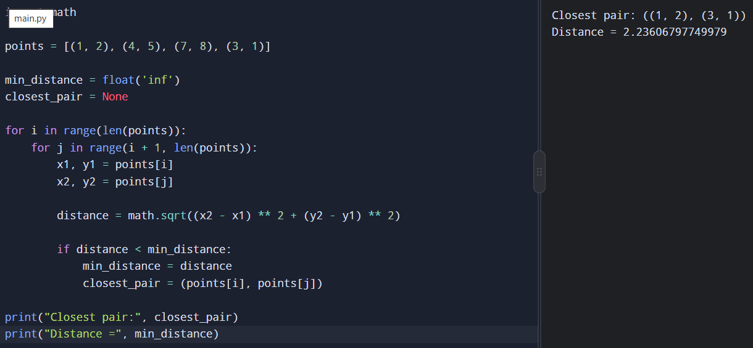
RESULT:
Thus, the closest pair was found successfully with distance √5.
EXP 2 : Exponentiation
AIM: To calculate power using fast recursive exponentiation.
CODE:
def power(x, n):
if n == 0:
return 1
half = power(x, n // 2)
if n % 2 == 0:
return half * half
else:
return x * half * half
print("Result =", power(2, 10))
OUTPUT:
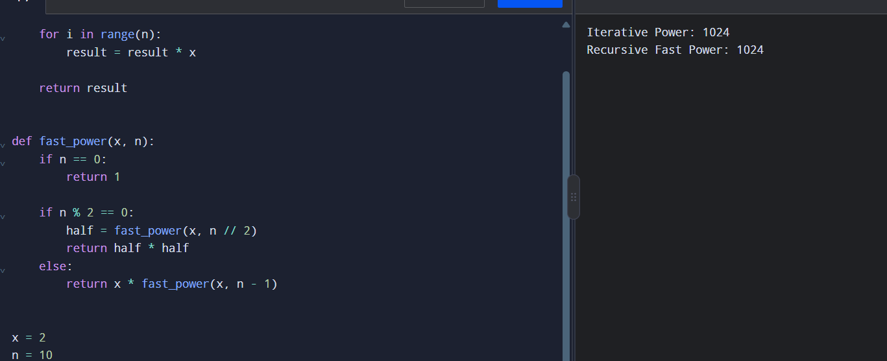
RESULT:
Thus, exponentiation was calculated successfully using recursion.

EXP 3 : Maximum Subarray Sum
AIM: To find the maximum subarray sum using Kadane's algorithm.
CODE:
a = [-2, -3, 4, -1, -2, 1, 5, -3]
current = maximum = a[0]
for x in a[1:]:
current = max(x, current + x)
maximum = max(maximum, current)
print("Maximum sum =", maximum)
OUTPUT:
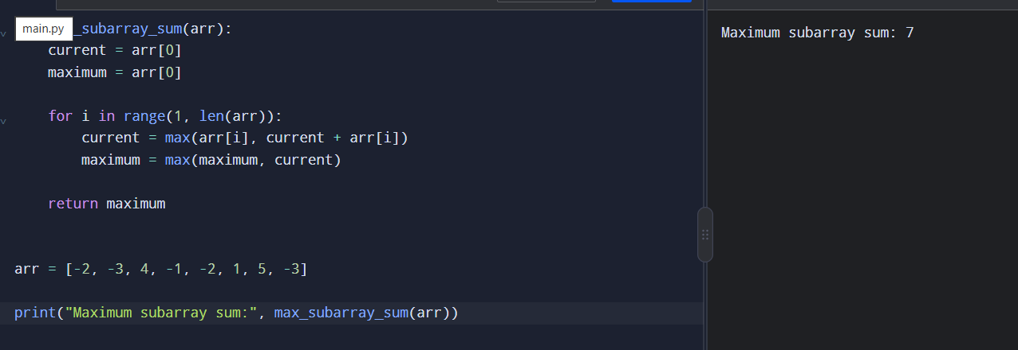
RESULT: Thus, the maximum subarray sum was found successfully.

EXP 4 - Counting Inversions
AIM: To count the number of inversions in an array.
CODE:
a = [2, 4, 1, 3, 5]
count = 0
for i in range(len(a)):
for j in range(i+1, len(a)):
if a[i] > a[j]:
count += 1
print("Inversions =", count)
OUTPUT:
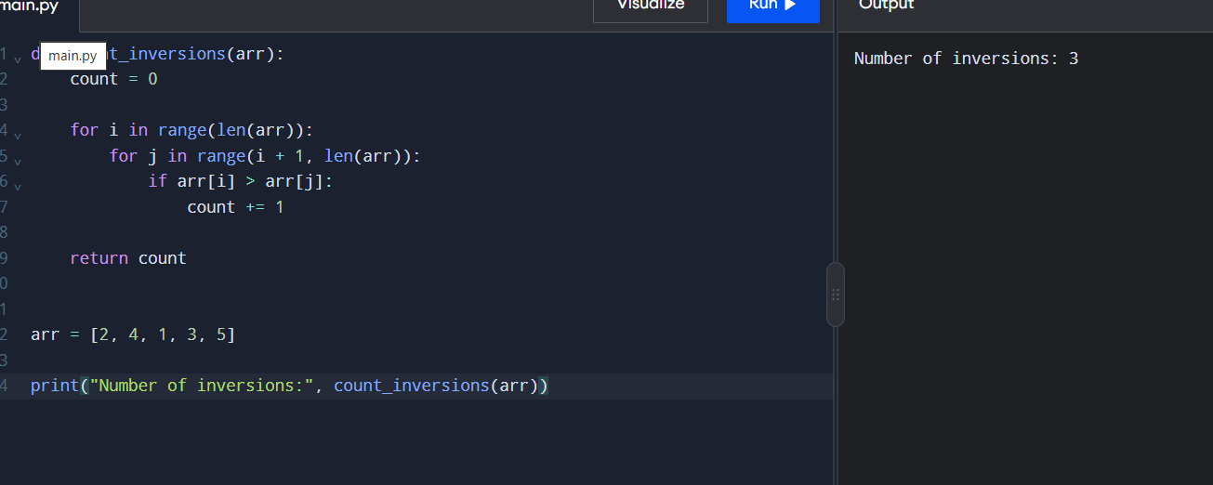
RESULT: Thus, the number of inversions was calculated successfully.

EXP 5 : Heap Sort
AIM: To sort an array using heap sort.
CODE:
import heapq
a = [4, 10, 3, 5, 1]
heapq.heapify(a)
result = []
while a:
result.append(heapq.heappop(a))
print(result)
OUTPUT:
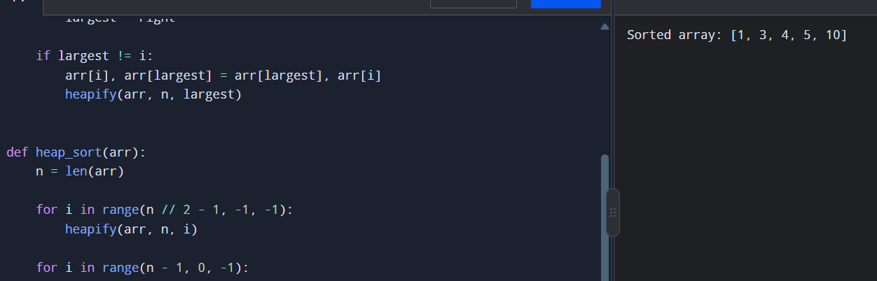
RESULT: Thus, the array was sorted successfully using heap sort.

EXP 6: Insertion Sort
Aim:
To sort an array using insertion sort
CODE:
def insertion_sort(a):
for i in range(1, len(a)):
key = a[i]
j = i – 1
while j >= 0 and a[j] > key:
a[j+1] = a[j]
j -= 1
a[j+1] = key
a = [12, 11, 13, 5, 6]
insertion_sort(a)
print(a)
OUTPUT:
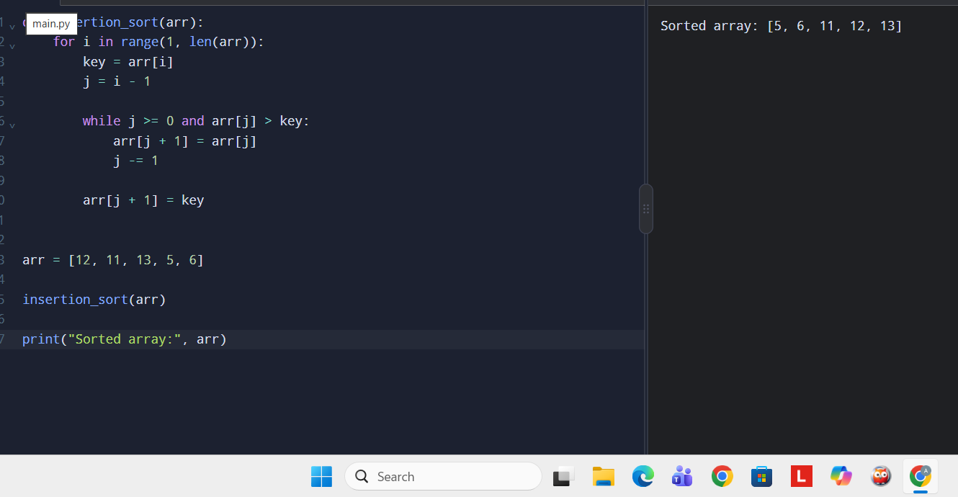
RESULT: Thus, the array was sorted successfully using insertion sort.

EXP 7: GCD
Aim:
To find GCD using the Euclidean algorithm.
Code:
def gcd(a, b):
if b == 0:
return a
return gcd(b, a % b)
print("GCD =", gcd(48, 18))
OUTPUT:
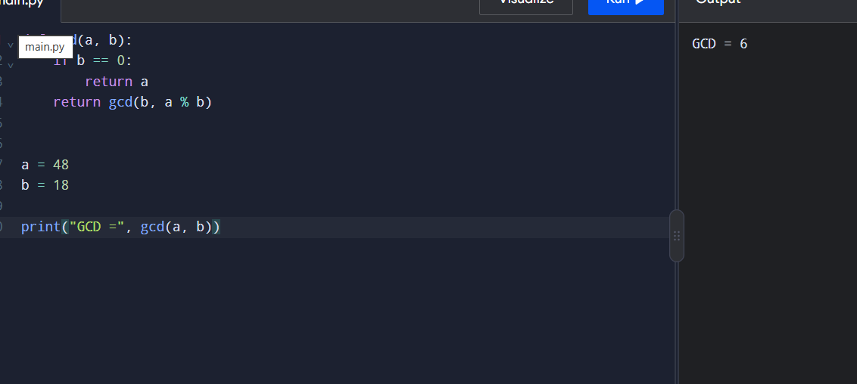
RESULT: Thus, the GCD was calculated successfully.

EXP 8 : Tower of Hanoi
AIM: To solve the Tower of Hanoi problem using recursion.
Code:
def hanoi(n, source, auxiliary, destination):
if n == 1:
print(source, "->", destination)
return
hanoi(n-1, source, destination, auxiliary)
print(source, "->", destination)
hanoi(n-1, auxiliary, source, destination)
hanoi(3, 'A', 'B', 'C')
OUTPUT:
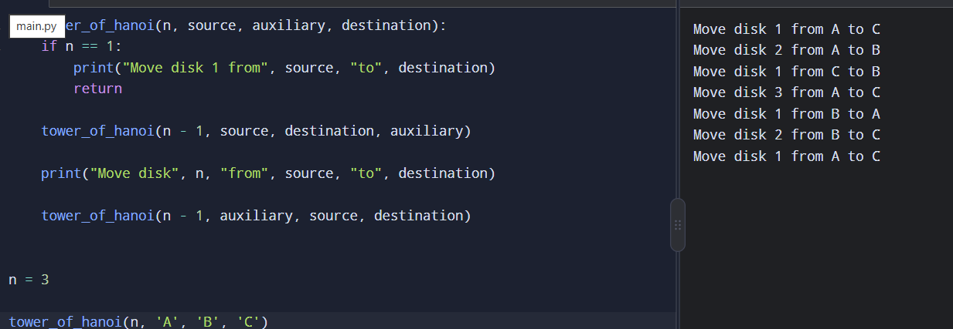
RESULT: Thus, the Tower of Hanoi was solved successfully using recursion.

EXP 9 : Quick Sort
Aim:
To sort an array using quick sort.
Code:
def quick_sort(a):
if len(a) <= 1:
return a
pivot = a[-1]
left = [x for x in a[:-1] if x <= pivot]
right = [x for x in a[:-1] if x > pivot]
return quick_sort(left) + [pivot] + quick_sort(right)
a = [10, 7, 8, 9, 1, 5]
print(quick_sort(a))
OUTPUT:
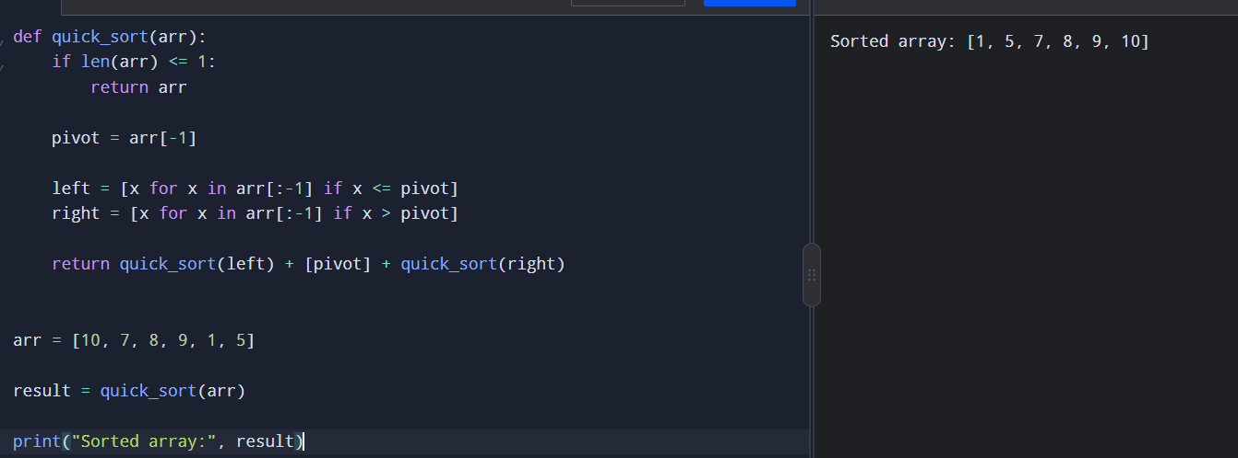
RESULT: Thus, the array was sorted successfully using quick sort.

EXP 10 : Merge Sort
Aim:
To sort an array using merge sort.
Code:
def merge_sort(a):
if len(a) > 1:
mid = len(a)//2
L = a[:mid]
R = a[mid:]
merge_sort(L)
merge_sort(R)
i = j = k = 0
while i < len(L) and j < len(R):
if L[i] < R[j]:
a[k] = L[i]
i += 1
else:
a[k] = R[j]
j += 1
k += 1
while i < len(L):
a[k] = L[i]
i += 1
k += 1
while j < len(R):
a[k] = R[j]
j += 1
k += 1

a = [38, 27, 43, 3, 9, 82, 10]
merge_sort(a)
print(a)
OUTPUT:
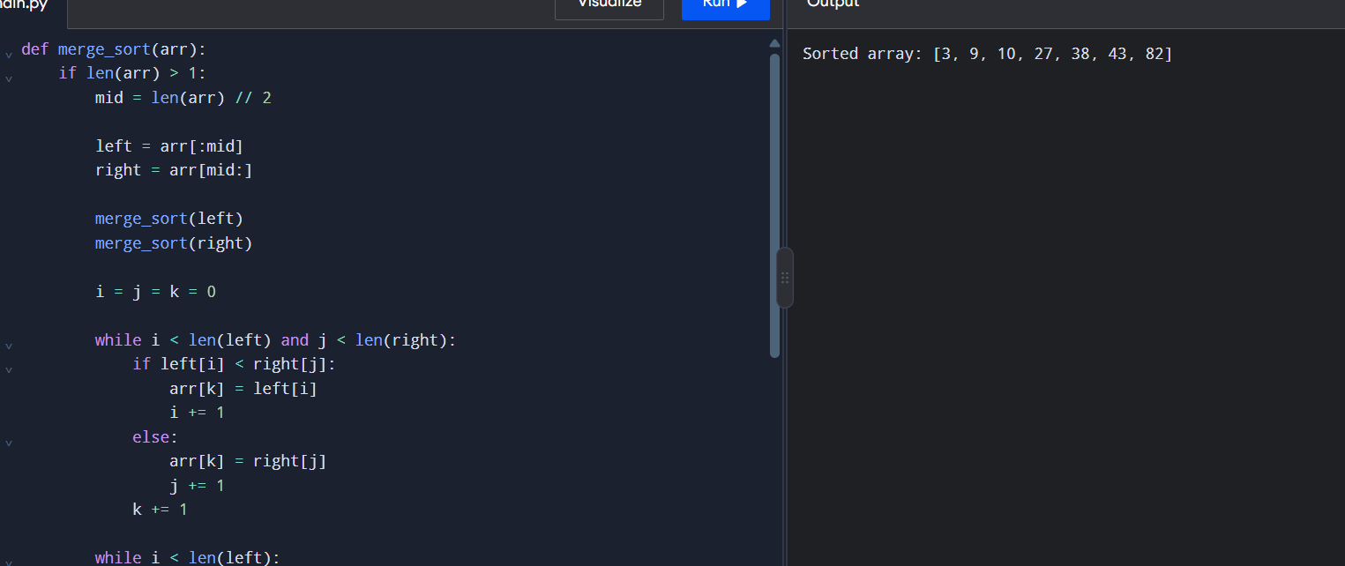
RESULT: Thus, the array was sorted successfully using merge sort.

11 Matrix Multiplication
Aim:
To multiply two matrices using nested loops.
Code:
A = [[1, 2], [3, 4]]
B = [[5, 6], [7, 8]]
C = [[0, 0], [0, 0]]
for i in range(2):
for j in range(2):
for k in range(2):
C[i][j] += A[i][k] * B[k][j]

print(C)
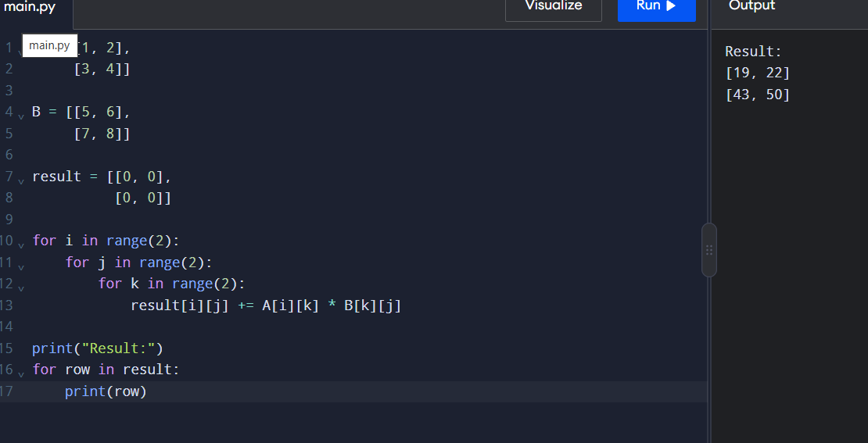
RESULT: Thus, the two matrices were multiplied successfully.

12 Fibonacci Series
Aim:
To generate the Fibonacci series using iteration.
Code:
n = 6
a, b = 0, 1
for i in range(n):
print(a, end=" ")
a, b = b, a + b
OUTPUT:
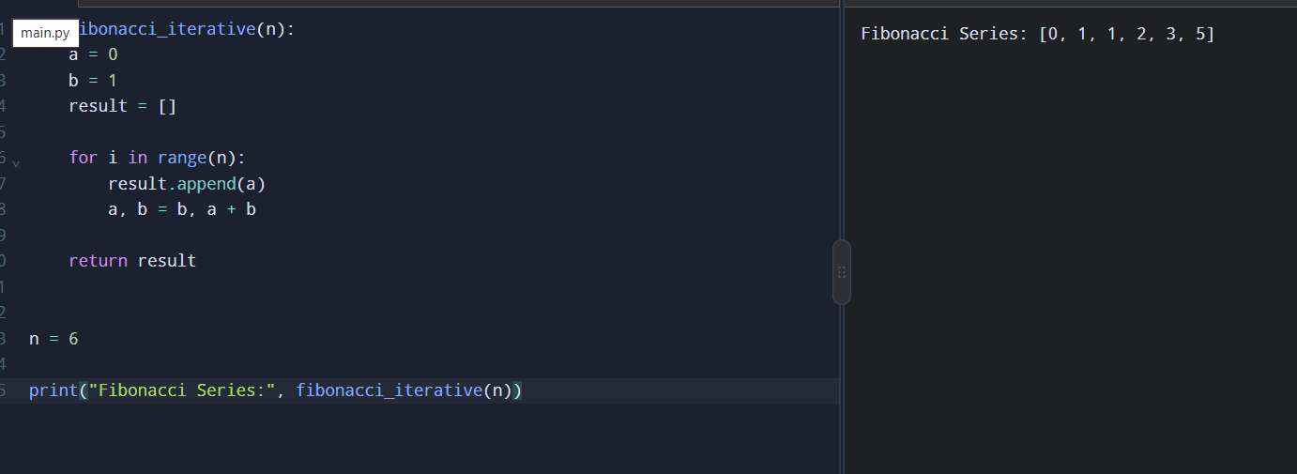
RESULT: Thus, the Fibonacci series was generated successfully.

13 Factorial
Aim:
To find factorial using iterative and recursive methods.
Code:
def iterative(n):
fact = 1
for i in range(1, n + 1):
fact *= i
return fact
def recursive(n):
if n == 0:
return 1
return n * recursive(n - 1)
n = 5
print("Iterative:", iterative(n))
print("Recursive:", recursive(n))
OUTPUT:
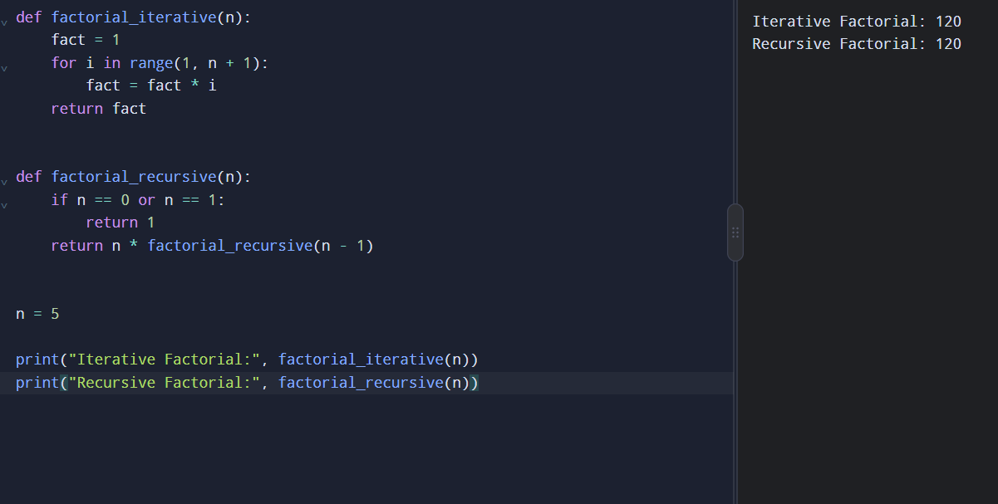
RESULT: Thus, factorial was calculated successfully using both methods.

14 Binary Search
Aim:
To search for an element using recursive binary search.
Code:
def binary_search(arr, low, high, key):
if low <= high:
mid = (low + high) // 2
if arr[mid] == key:
return mid
elif key < arr[mid]:
return binary_search(arr, low, mid - 1, key)
else:
return binary_search(arr, mid + 1, high, key)
return -1
arr = [5, 10, 15, 20, 25]
key = 20
print("Key found at index",
binary_search(arr, 0, len(arr)-1, key))
OUTPUT:
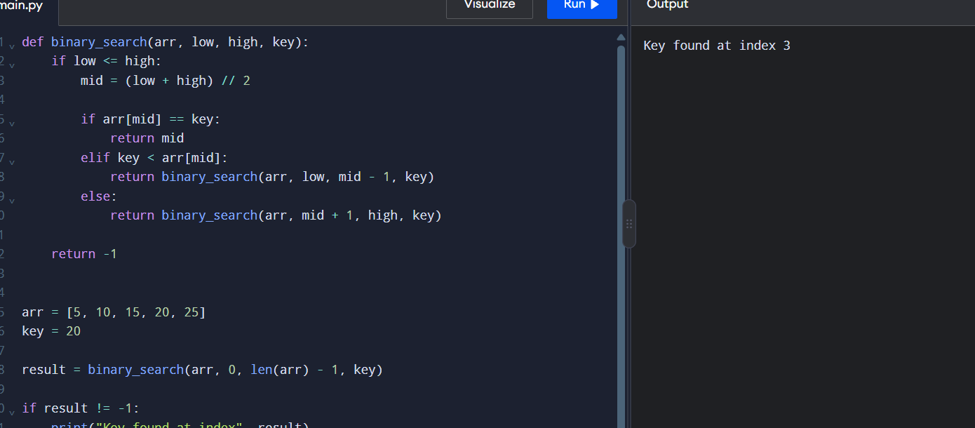
RESULT: Thus, the key was successfully found using binary search.
15 Linear Search
Aim:
To search for an element using linear search.
Code:
arr = [10, 25, 30, 45, 50]
key = 30
for i in range(len(arr)):
if arr[i] == key:
print("Key found at index", i)
break
OUTPUT:
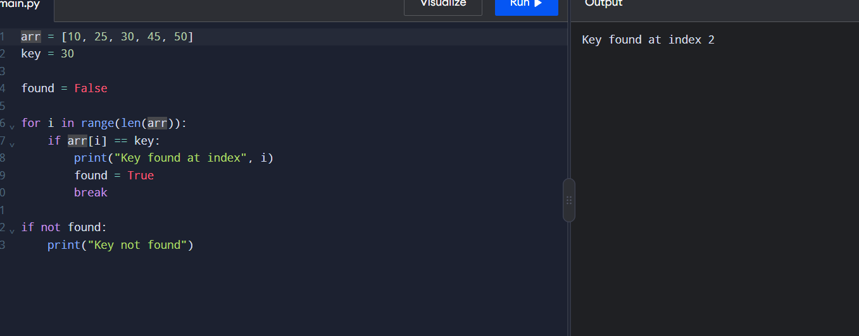
RESULT: Thus, the key was successfully found using linear search.

